**CONTRACTOR DAILY REPORT (CDR)**

|  |  |  |  |  |  |  |  |
| --- | --- | --- | --- | --- | --- | --- | --- |
| **Project Name :** **EIPICO 3, Biologicals and Biosimilars Manufacturing Facility.**  **Project No. :** **1250**  **Employer :** **EIPICO** | | | | **Package :** **EIPICO 3**  **Phase :** **EIPICO 3**  **Contractor:** **ROWAD MODERN Engineering** | | | |
| **Site Supervision Consultant:** **EHAF Consulting Engineers** | | | | | | | |
| **From :** **ROWAD MODERN Engineering**  **To :** **EGYCAN**  **Attn. :** **Eng. Ibrahim Tawfik** | | | | **Date :** **19/11/2023**  **Ref. :** **1250/CDR/RME/EGYCAN/2023/310**  **Report No. : 310** | | | |
| **Weather Condition:** | | | | | | | |
| Clear | Windy | Cool | | | Overcast | Foggy | |
| Worm | Rainy | Cold | | | Hot |  | |
| **Temprature Rang :** ------------------------------------------------------------------------------------------------------- | | | | | | | |
| **Site Condition :** -------------------------------------------------------------------------------------------------------- | | | | | | | |
|  | Clear | | Dusty | | Muddy | | Other |

|  |  |  |  |  |  |
| --- | --- | --- | --- | --- | --- |
| **Activities** | | | | | |
| **ID** | **location** | **On Site Activities Description** | **Planned Completion Date** | **Actual Completion Date** | **Commentary** |
|  | **B02**  **Ground Floor** | **Cont. installation of electrical conduits at level-1** |  |  |  |
|  | **B02**  **Gr floor** | **Installation of galvanized ducts- GR floor** |  |  |  |
|  | **B2-level 01** | **Installation of Fire Fighting Pipes at B02- level 01** |  |  |  |
|  | **B01**  **Risers** | **Cont. installation of drainage pipes at B01-risers** |  |  |  |
|  | **B02**  **1st floor** | **Installation of galvanized ducts- 1st floor** |  |  |  |
|  | **B4** | **Installation of chilled works at B04** |  |  |  |
|  | **B01**  **GR floor** | **Cont. installation of electrical conduits at B01-Ground Floor** |  |  |  |
|  | **B02**  **1st floor** | **Cont. installation of Hangers & Support for cable trays** |  |  |  |
|  | **Utility** | **Plaster works - chiller** |  |  |  |
|  | **Utility** | **Boiler installation** |  |  |  |
|  | **Utility** | **Plaster - Facade** |  |  |  |
|  | **Transformer** | **Plaster – internal and facade** |  |  |  |
|  | **Warehouse** | **Blockwork GF** |  |  |  |
|  | **Warehouse** | **Plaster work GF** |  |  |  |
|  |  |  |  |  |  |
|  |  |  |  |  |  |
|  |  |  |  |  |  |
|  |  |  |  |  |  |
|  | **EIPICO 3 Overall** | **Documentation Works – (Preparing Transmittals, Reports…., etc.)** |  |  |  |

|  |  |  |  |  |  |  |  |  |
| --- | --- | --- | --- | --- | --- | --- | --- | --- |
| **Equipment** | | | | | | | | |
| **ID** | **Name** | **Type** | **Model** | **Age** | **No** | **In use Hrs** | **Standby Hrs** | **Commentary** |
| **1** | **Total Station** |  |  |  | **1** | **Hrs** |  |  |
| **2** | **Level** |  |  |  | **1** | **Hrs** |  |  |
| **3** | **Generator 500 KVA** |  |  |  | **2** | **Hrs** |  |  |
| **4** | **Forklift** |  |  |  | **2** | **Hrs** |  |  |
| **5** | **Loader 36 (Teeth & Bucket)** |  |  |  | **1** | **Hrs** |  |  |
| **6** | **JCP** |  |  |  | **1** | **Hrs** |  |  |
| **7** | **Trailer (9m3) and tractor** |  |  |  | **1** | **Hrs** |  |  |
| **8** | **Mobile crane** |  |  |  | **1** | **Hrs** |  |  |
| **9** | **Pump** |  |  |  | **1** | **Hrs** |  |  |
| **10** | **Loader 66** |  |  |  | **2** | **Hrs** |  |  |

|  |  |  |  |  |
| --- | --- | --- | --- | --- |
| **Manpower** | | | | |
| **ID** | **Trade / Position** | **No** | **Hours** | **Commentary** |
| **1** | **Project manager** | **1** | **9 Hrs** |  |
| **2** | **Construction manager** | **1** | **9 Hrs** |  |
| **3** | **Technical Office Team Leader** | **1** | **9 Hrs** |  |
| **4** | **Civil engineer** | **3** | **9 Hrs** |  |
| **5** | **Q.C. Engineer** | **5** | **9 Hrs** |  |
| **6** | **Planning Engineer** | **2** | **9 Hrs** |  |
| **7** | **Mechanical TO Manager** | **1** | **9 Hrs** |  |
| **8** | **Mechanical Tech. Office Engineer** | **1** | **9 Hrs** |  |
| **9** | **Electrical Tech. Office Engineer** | **1** | **9 Hrs** |  |
| **10** | **Civil Tech. Office Engineer** | **3** | **9 Hrs** |  |
| **11** | **Arch Tech. Office Engineer** | **1** | **9 Hrs** |  |
| **12** | **BIM Coordinator** | **1** | **9 Hrs** |  |
| **13** | **Supervisor** | **5** | **9 Hrs** |  |
| **14** | **Document Controller** | **3** | **9 Hrs** |  |
| **15** | **Safety Manager** | **1** | **9 Hrs** |  |
| **16** | **Safety Officer** | **4** | **9 Hrs** |  |
| **17** | **Accountant** | **1** | **9 Hrs** |  |
| **18** | **Administrator** | **1** | **9 Hrs** |  |
| **19** | **Survey Engineer** | **1** | **9 Hrs** |  |
| **20** | **Surveyor** | **6** | **9 Hrs** |  |
| **21** | **Security** | **2** | **9 Hrs** |  |
| **22** | **Timekeeper** | **1** | **9 Hrs** |  |
| **23** | **Electrician Assistant** | **4** | **9 Hrs** |  |
| **24** | **Bobcat Driver** | **1** | **9 Hrs** |  |
| **25** | **Storekeeper** | **1** | **9 Hrs** |  |
| **26** | **Material Supervisor** | **1** | **9 Hrs** |  |
| **27** | **Purchasing Officer** | **1** | **9 Hrs** |  |
| **28** | **Lab Technician** | **1** | **9 Hrs** |  |
| **29** | **Office Boy** | **2** | **9 Hrs** |  |
| **30** | **Plumber** | **2** | **9 Hrs** |  |
| **31** | **Drivers** | **5** | **9 Hrs** |  |
| **32** | **Storekeeper Helper** | **1** | **9 Hrs** |  |
| **33** | **Nurse** | **1** | **9 Hrs** |  |
|  | **Total Indirect Manpower** | **58** |  |  |
| **34** | **Carpenters** | 14 | **9 Hrs** |  |
| **35** | **Steel Fixer** | 2 | **9 Hrs** |  |
| **36** | **Scaffolding Technician** | 29 | **9 Hrs** |  |
| **37** | **Farmaga** | 16 | **9 Hrs** |  |
| **38** | **Labors** | 50 | **9 Hrs** |  |
| **39** | **Plaster** | 55 | **9 Hrs** |  |
| **40** | **Sculptor** | 7 | **9 Hrs** |  |
| **41** | **Masonry** | 30 | **9 Hrs** |  |
| **42** | **Painter** | 5 | **9 Hrs** |  |
| **43** | **Insulation Technician** | 0 | **9 Hrs** |  |
| **45** | **Welders** | 4 | **9 Hrs** |  |
| **46** | **Electricians** | 30 | **9 Hrs** |  |
| **47** | **Plumber** | 15 | **9 Hrs** |  |
| **48** | **Mechanicians** | 51 | **9 Hrs** |  |
| **49** | **Tilling workers** | 10 | **9 Hrs** |  |
| **50** | **Aluminum tech** | 20 | **9 Hrs** |  |
| **51** | **Steel structure tech** | 0 | **9 Hrs** |  |
|  | **Total direct Manpower** | 388 |  |  |

|  |  |  |  |  |  |  |  |
| --- | --- | --- | --- | --- | --- | --- | --- |
| **Total Direct Manpower** | | **Planned As Per Approved Programme** | | | **Actual** | | |
|  | |  | | | 338 | | |
| **Materials** | | | | | | |
| **ID** | **Material description** | | **Quantity on site** | **Quantity installed** | | **Commentary** |
| **1** |  | |  |  | |  |
| **2** |  | |  |  | |  |
| **3** |  | |  |  | |  |
| **4** |  | |  |  | |  |
| **5** |  | |  |  | |  |
| **6** |  | |  |  | |  |
| **7** |  | |  |  | |  |
| **8** |  | |  |  | |  |
| **9** |  | |  |  | |  |
| **10** |  | |  |  | |  |

|  |  |  |  |  |  |  |
| --- | --- | --- | --- | --- | --- | --- |
| **Tests/ Inspections** | | | | | | |
| **ID** | **Material Description** | **Specs.**  **Ref.** | **Drawings**  **Ref.** | **Name Of Tester** | **Results** | **Commentary** |
| **1** |  |  |  |  |  |  |

|  |  |  |  |  |  |
| --- | --- | --- | --- | --- | --- |
| **Safety measures** | | | | | |
| **ID** | **Instructor Name** | **Title** | **Represents** | **Instruction Description** | **Commentary** |
| **1** |  |  |  |  |  |

|  |  |  |  |  |  |  |  |
| --- | --- | --- | --- | --- | --- | --- | --- |
| **Official Visitors Today** | | | | | | | |
| **ID** | **Visitor Name** | **Title** | **Represents** | **Visit** | | | **Commentary** |
| **From** | | **To** |
|  |  |  |  |  | |  |  |
| **Area of Concern:** | | | | | | | |
| **Nature of Exceptions / Defects (Include Specifications and / or Drawings Numbers, Location, Description):** | | | | | | | |
| **Attachments :** ------------------------------------------------------------------------------------------------------------------------------------------------------------------------------------------------------ | | | | | -------------------------------------------  **Contractor**  Authorized Representative  **Date**  ---------/-----------/------------- | | |

**Progress Photos**

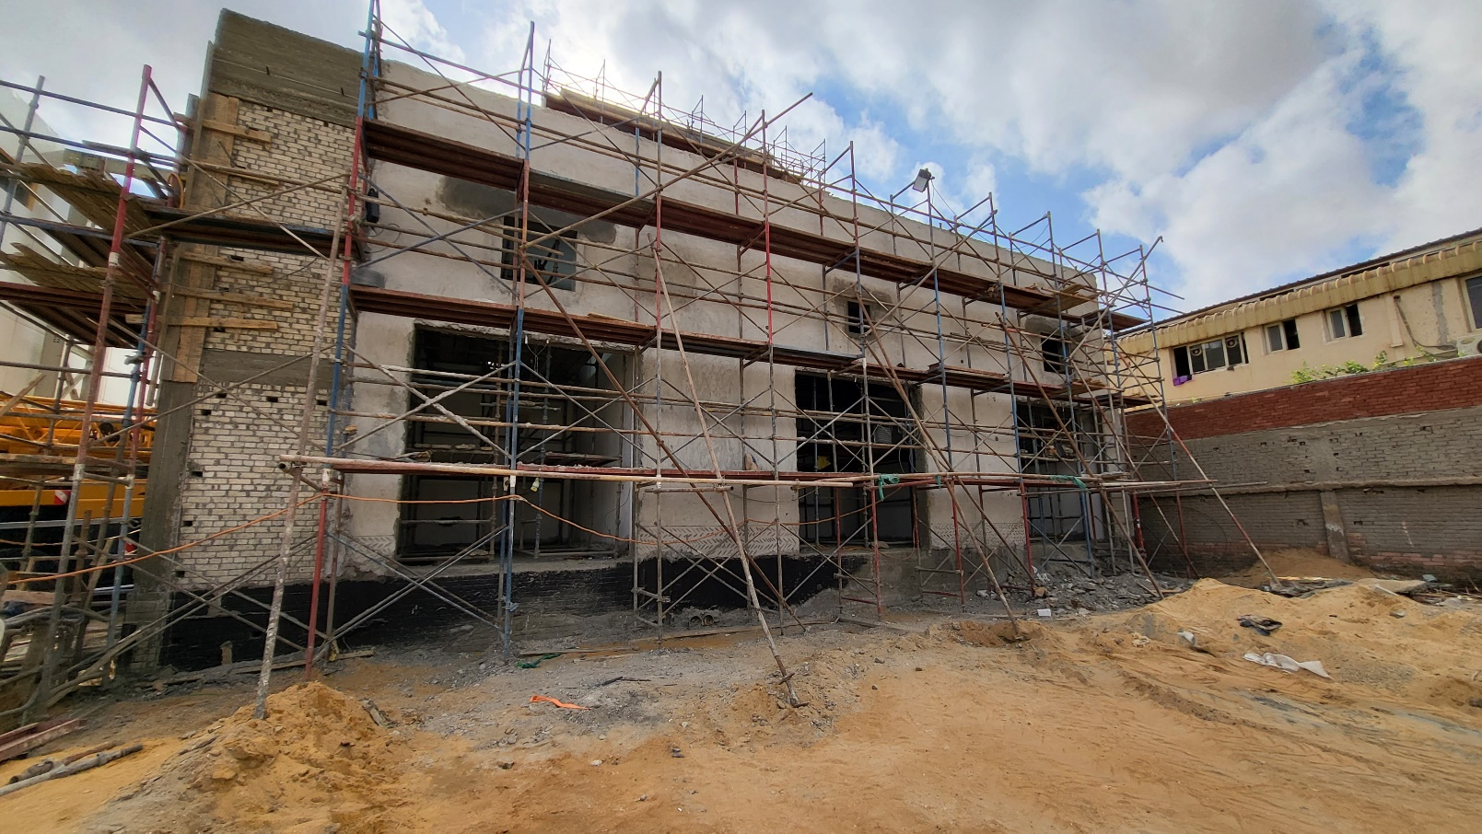

**Transformer**

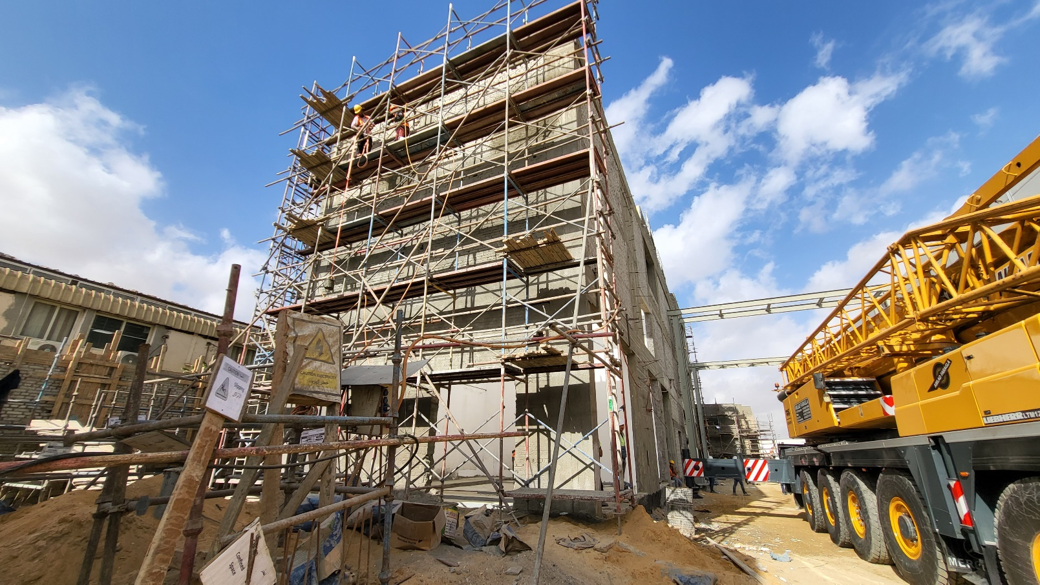

**Utility**

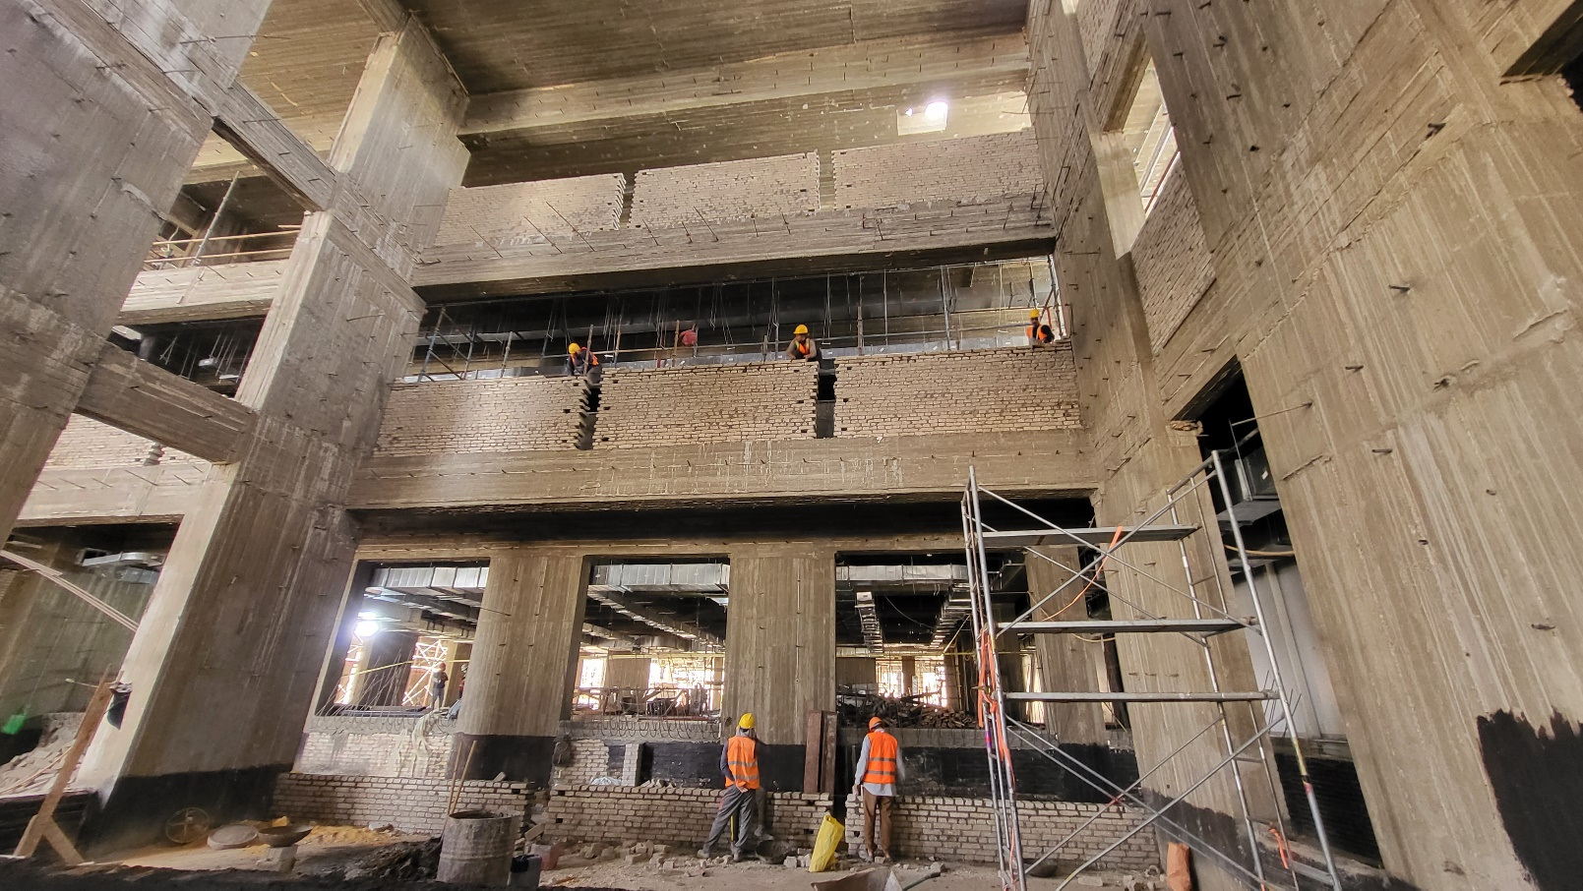

**Warehouse**